FKA TWIGS RETURNS WITH NEW SINGLE ‘CELLOPHANE’

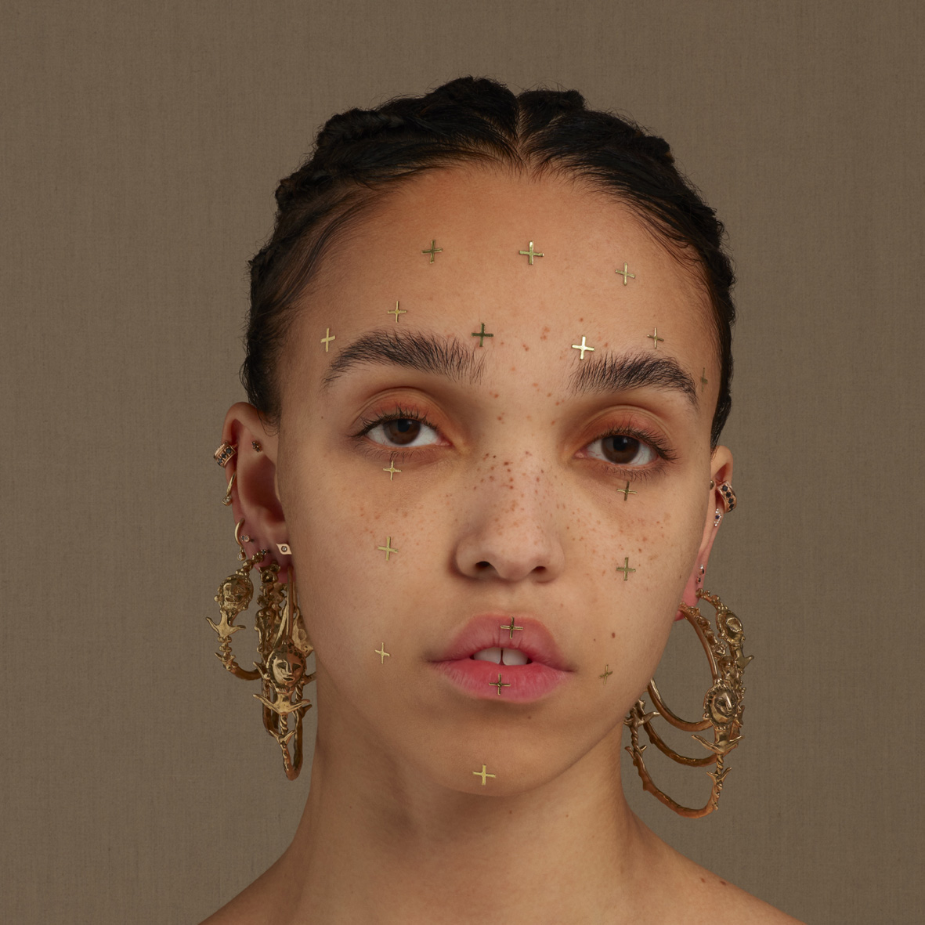
(single artwork by Matthew Stone. Download high res HERE)

FKA twigs today returns with her first new music in over three years. Written and produced by FKA twigs with Jeff Kleinman and Michael Uzowuru, ‘Cellophane’ is twigs’ most vulnerable song to date and is an enticing first glimpse of what to expect from her second album; the follow up to her Mercury Prize and Brit Award nominated 2014 debut, LP1.

Talking about the process, FKA twigs says: “throughout my life I’ve practiced my way to being the best I could be, it didn’t work this time. I had to tear down every process I'd ever relied on. go deeper. rebuild. start again”

‘Cellophane’ is accompanied by a video directed by Andrew Thomas Huang. The video is a powerful visual contrast to the vulnerability of the song’s lyrics (“Didn’t I do it for you? Why don’t I do It for you?”) and stars FKA twigs in a role that she trained for months in advance for, adding another facet to her enviable multi-disciplinary skill set.

In FKA twigs own words: “when I wrote cellophane over a year ago a visual narrative came to me immediately, I knew I had to learn how to pole-dance to bring it to life, and so that’s what I did. thank you @andrewthomashuang, for elevating my vision beyond words. you are a visionary. @kellyvon thank you for being with me every step of the way on my precious pole yellow brick road. working with you both on this is a dream come true."

Watch the ‘Cellophane’ video HERE

Download / stream ‘Cellophane’ HERE


(download high res video stills HERE)

Meanwhile, FKA twigs is set to perform live around the world over the summer. In addition to global festival appearances, the run of dates includes two sold out headline shows at New York’s Park Avenue Armory, which will see twigs performing in New York for the first time since dazzling audiences with her Congregata show in 2015. She also recently hinted at further live dates – for more information fans can sign up via https://signup.fkatwi.gs/

FKA twigs Live 2019 - Confirmed Dates So Far

07 May Venue TBA, Los Angeles CA, USA
08 May Venue TBA, Los Angeles CA, USA
11 May Park Avenue Armory, New York NY, USA (sold out)
12 May Park Avenue Armory, New York NY, USA (sold out)
24 May Venue TBA, Berlin, Germany
28 May Venue TBA, London, UK
30 May Primavera Sound, Barcelona, Spain
01 June We Love Green, Paris, France
09 June Carriageworks, Sydney, Australia
14 June Dark Mofo at Mac 2, Hogart, Australia
25 August AFROPUNK Festival, Brooklyn NY, USA

FKA twigs official site / Instagram / Facebook / Twitter / YouTube

